**LAB 5**

**SAZZAD HOSSEN**

**2019-1-60-063**

**JAVA FILE:**

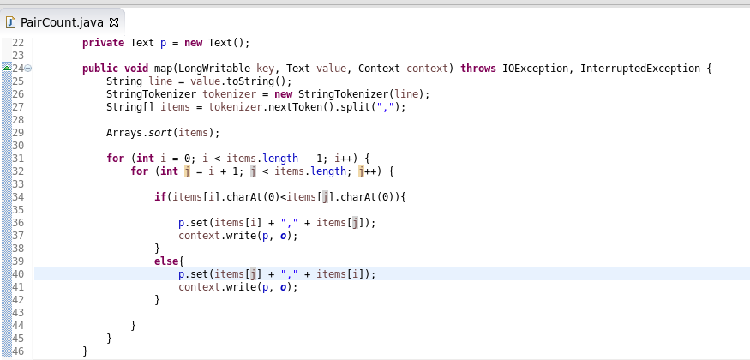

**JAR file Create “Pair Count”:**

**Dataset input in Hue Cloudera:**

**Run in Terminal:**

**Output:**

